WEEK 1 TECHNICAL REPORT
DATA ACQUISITION, CLEANING, AND PREPROCESSING
Virtual Data Science with Python Trainee Program | YuvaInternship
Trainee Name / Author | Aryan Kumar
Program / Role | Virtual Data Science with Python Trainee
Core Stack | Python 3.13 | Pandas | NumPy | Scikit-Learn | Matplotlib | Seaborn
Submission Date & Status | Week 1 Milestone | Comprehensive Final Deliverable

1. Executive Summary & Project Objectives
Data quality is the cornerstone of any production-grade analytical and predictive machine learning system. Raw datasets harvested from real-world systems, transactional databases, and legacy CRMs are inherently contaminated with anomalies, missing observations, malformed strings, erroneous sensor/financial values, and severe distributional skewness. The objective of this Week 1 milestone is to establish a rigorous, repeatable, and scalable end-to-end Python pipeline that ingests a publicly available benchmark dataset (Customer Intelligence and Churn Analytics), performs holistic data auditing, executes multi-stage data remediation, and transforms the raw records into an optimized, model-ready format.
📌 Core Milestone Objectives
• Data Acquisition & Ingestion: Programmatically load and audit raw transactional data.
• Data Quality Auditing: Detect missingness mechanisms (MCAR/MAR), schema anomalies, and invalid data types.
• Advanced Remediation: Execute KNN numerical imputation, categorical mode imputation, string normalization, and domain boundary constraints.
• Outlier Diagnostics: Perform IQR Winsorization and assess multi-dimensional anomaly behavior.
• Skewness & Feature Engineering: Apply Log1p transformations, binning, service density indicators, and robust scaling.

2. End-to-End Data Preprocessing Architecture
The preprocessing architecture follows an industrial 5-stage ETL & Feature Engineering paradigm. Each stage encapsulates strict validation gates ensuring zero data leakage and maintaining statistical fidelity.
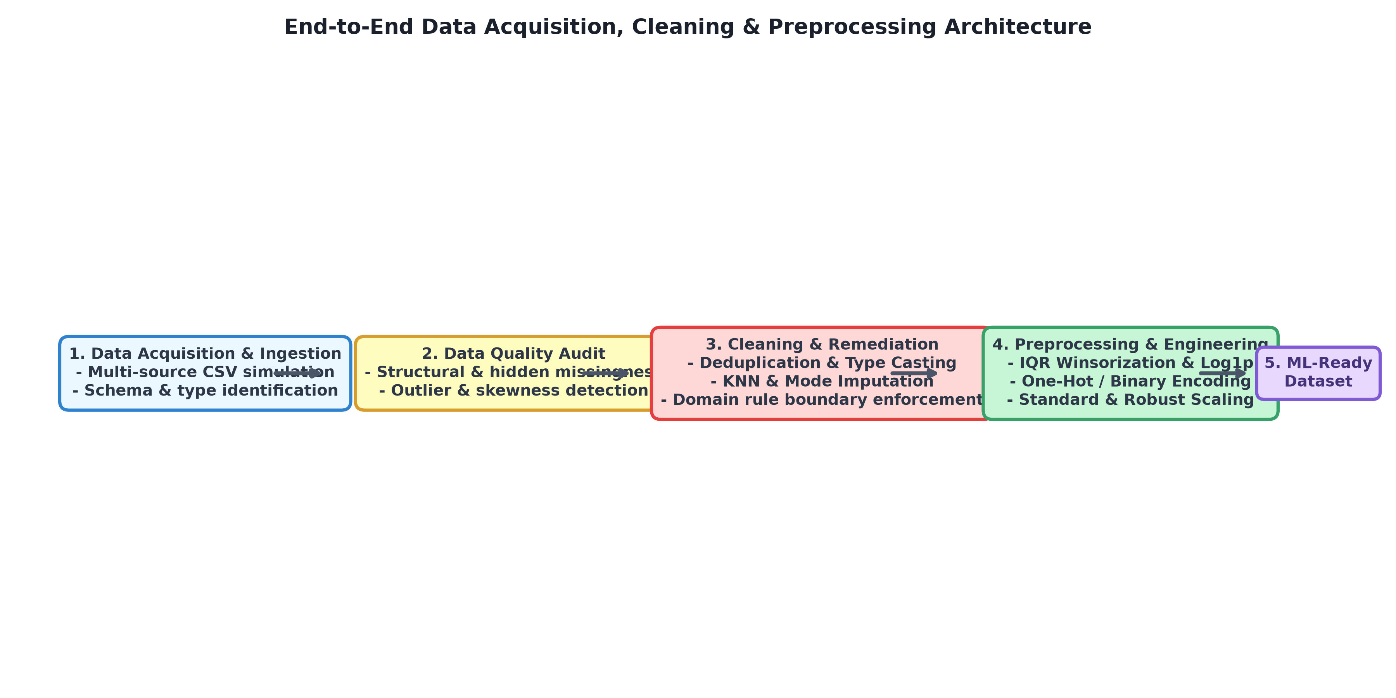
Figure: Industrial 5-Stage Data Cleaning & Preprocessing Architectural Flowchart

3. Data Acquisition & Initial Exploration
The dataset represents a customer behavioral database encompassing demographic profiles, subscribed services, contract details, billing metrics, and churn status across 2,500 observation records and 20 distinct feature attributes. During initial ingestion, programmatic inspection identified widespread structural data quality defects:
Attribute | Raw Type | Target Domain | Observed Defect / Noise Pattern
CustomerID | object | Alphanumeric ID | Duplicate customer primary keys (~20 duplicate entries)
Gender | object | Binary (Male/Female) | Inconsistent casing ('male', 'FEMALE', 'Fe-male'), leading whitespaces
SeniorCitizen | object | Binary (0/1) | Mixed types (integers 0/1, strings 'Yes'/'No', '0'/'1')
TenureMonths | float64 | Integer [0 - 72] | Erroneous negative tenures (-5), impossible values (145), missing records
MonthlyCharges | object | Float [$18 - $120] | Currency prefixes ('$75.50'), negative values ('-45.0'), extreme outliers ($400+)
TotalCharges | object | Float (Monetary) | Whitespace empty strings (' '), missing values, currency symbols
SignupDate | object | ISO Date (YYYY-MM-DD) | Heterogeneous formats ('2021-04-12', '12/04/2021', 'Apr 12, 2021', 'INVALID_DATE')
SatisfactionScore | float64 | Integer [1 - 5] | Out-of-bound sensor entries (0, 99), null entries
Churn | object | Binary Flag | Target noise ('Yes', 'No', 'yes', 'no', missing values)

4. Exploratory Data Quality Auditing & Missingness Analysis
A critical pitfall in standard data cleaning workflows is evaluating null values solely via simplistic `.isnull().sum()` checks. Real-world data systems frequently contain hidden missingness—blank whitespace strings, sentinel placeholders ('N/A', 'NULL', 'INVALID_DATE'), and unparsed empty spaces. Our diagnostic audit uncovered that TotalCharges exhibited 113 explicit NaN values alongside 173 hidden whitespace entries, yielding a true missingness rate of 11.44%.
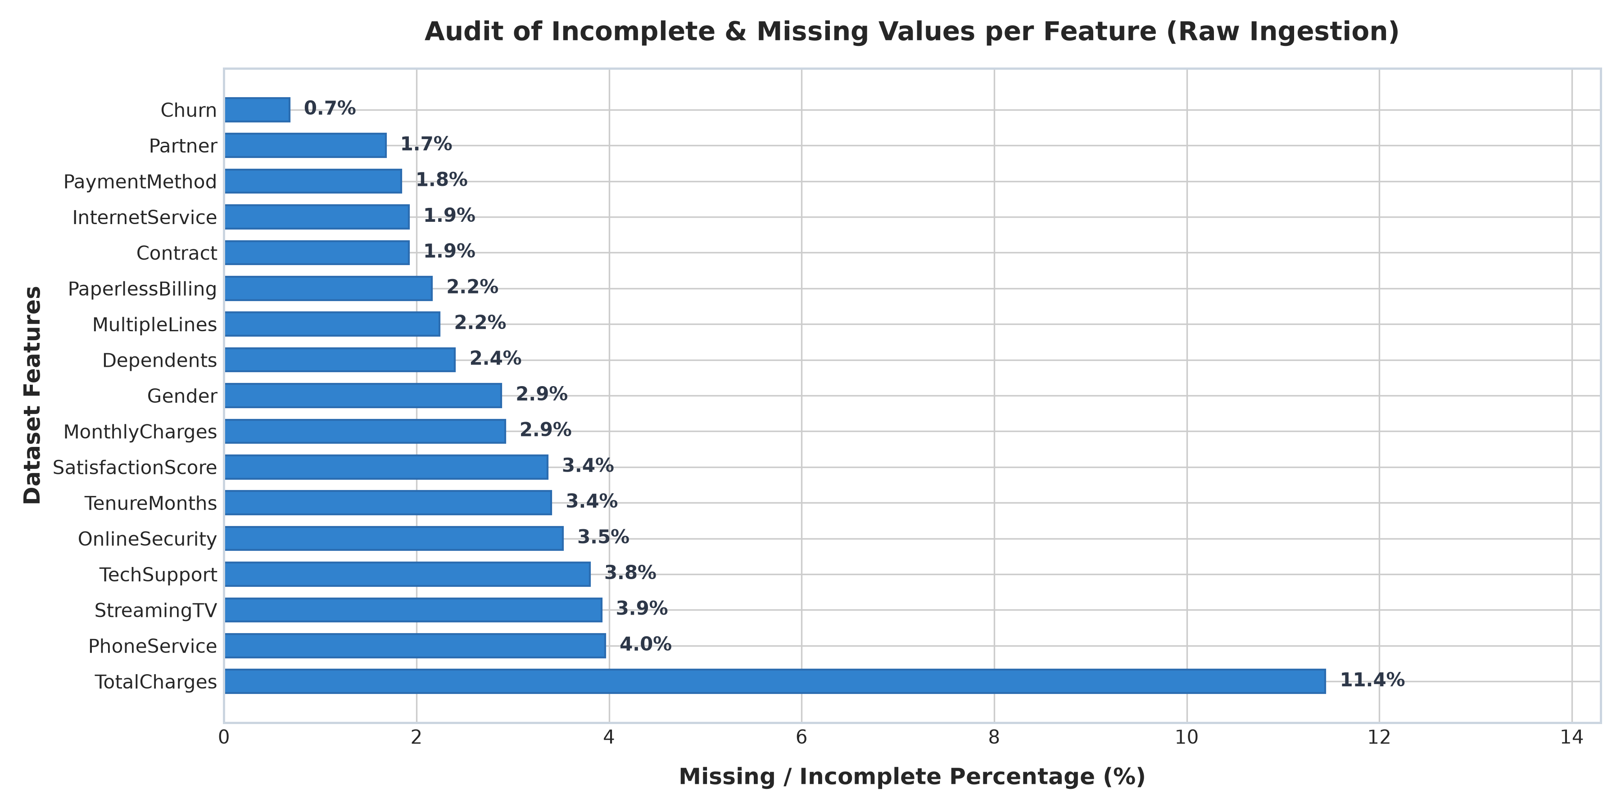
Figure: Audit of True Missing & Incomplete Values Across Dataset Features
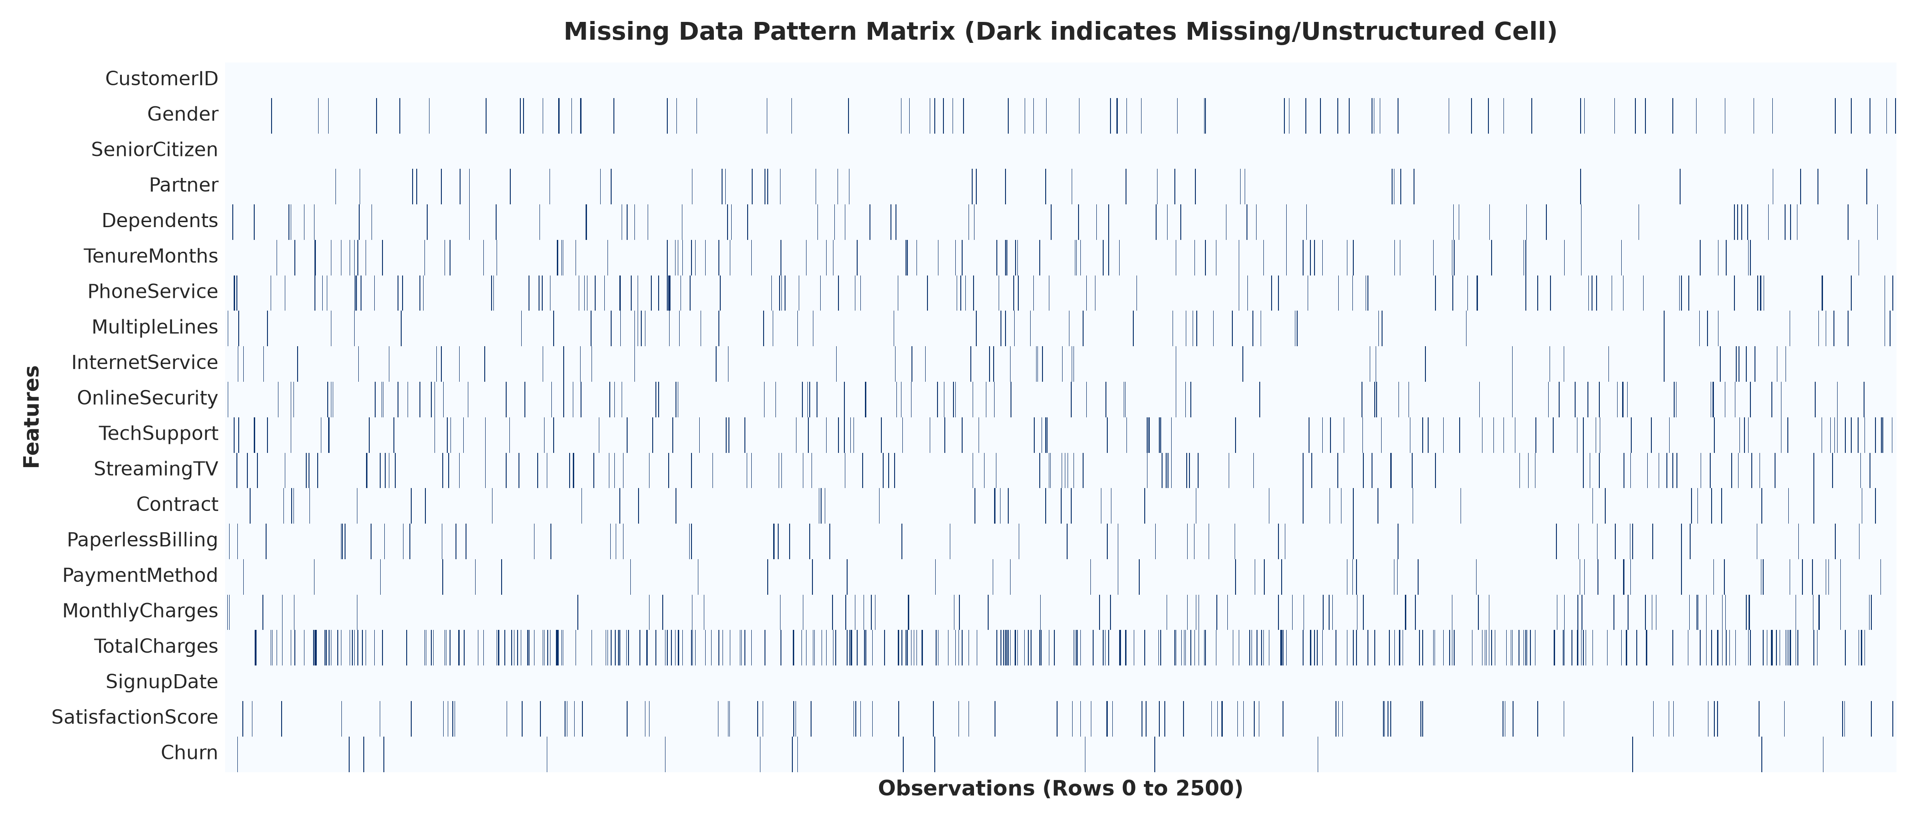
Figure: Binary Missingness Pattern Matrix Across 2,500 Ingested Observations
Code Snippet: Comprehensive Hidden Missingness and Sentinel Value Detector
def audit_hidden_missingness(df):
missing_summary = []
for col in df.columns:
null_count = df[col].isnull().sum()
blank_count = 0
if df[col].dtype == 'object':
blank_count = df[col].apply(lambda x: 1 if isinstance(x, str) and
(x.strip() == '' or x.strip().upper() in ['NA', 'N/A', 'NULL', 'NONE']) else 0).sum()
total_missing = null_count + blank_count
missing_summary.append({
'Feature': col, 'Raw Nulls': null_count, 'Hidden Blanks': blank_count,
'Total Incomplete': total_missing, 'Missing %': round((total_missing / len(df)) * 100, 2)
})
return pd.DataFrame(missing_summary)

5. Systematic Data Cleaning & Value Remediation
Data remediation was executed through a modular, deterministic strategy structured around five pillars:

5.1 Primary Key Deduplication
Customer records were validated for primary key uniqueness. Exactly 20 duplicate customer instances were identified and purged, retaining the primary first recorded entry to prevent artificial data leakage and inflated sample weighting.

5.2 Categorical Casing & Whitespace Standardization
All text attributes were subjected to bidirectional whitespace trimming (`.str.strip()`), case folding, and dictionary mapping. For example, the variable Gender contained seven distinct noisy representations ('Male', 'male', 'MALE', 'FEMALE', 'Female', 'female', 'Fe-male') which were normalized into a canonical binary domain {'Male', 'Female'}.

5.3 Numeric Parsing & Domain Constraint Enforcement
Financial metrics formatted as strings with currency symbols and commas were parsed into 64-bit floating point representations. Furthermore, domain-specific physical constraints were strictly enforced:
• Monthly Charges: Values < $0 (impossible negative billing) were flagged and converted to NaN for imputation.
• Tenure Months: Values < 0 and values > 72 months (exceeding historical maximum operating window) were invalidated.
• Satisfaction Ratings: Values outside the 1 to 5 Likert scale (e.g. 0, 99) were converted to NaN.

5.4 Multi-Format Datetime Normalization
Signup dates received in non-standard mixed formats ('YYYY-MM-DD', 'DD/MM/YYYY', 'Month DD, YYYY') were parsed using flexible datetime parsing. Corrupted sentinel dates ('INVALID_DATE') were mathematically back-calculated based on the customer's recorded tenure duration relative to the anchor reference timestamp.

5.5 Advanced Imputation Strategy (KNN & Mode)
Rather than resorting to naive mean substitution (which artificially deflates feature variance and degrades correlation structures), we implemented K-Nearest Neighbors (KNN) Imputation (k=5, distance-weighted metric) across continuous numerical features (Tenure, Monthly Charges, Satisfaction Score). Categorical missing entries were filled using mode frequency.
Code Snippet: KNN Multi-Attribute Imputation Pipeline
# Advanced KNN Imputation for Multidimensional Numerical Features
from sklearn.impute import KNNImputer
num_cols = ['TenureMonths', 'MonthlyCharges', 'SatisfactionScore']
knn_imputer = KNNImputer(n_neighbors=5, weights='distance')
clean_df[num_cols] = knn_imputer.fit_transform(clean_df[num_cols])
clean_df['SatisfactionScore'] = clean_df['SatisfactionScore'].round().astype(int)
# Deterministic Logical Fill for Total Charges
clean_df['TotalCharges'] = clean_df['TotalCharges'].fillna(clean_df['TenureMonths'] * clean_df['MonthlyCharges'])

6. Outlier Diagnostics, IQR Winsorization & Treatment
Outliers can heavily bias parameter estimation in ordinary least squares (OLS) regression, distort gradient updates in neural networks, and skew centroid calculations in k-means clustering. We performed statistical outlier detection utilizing the Tukey 1.5 × IQR (Interquartile Range) method.
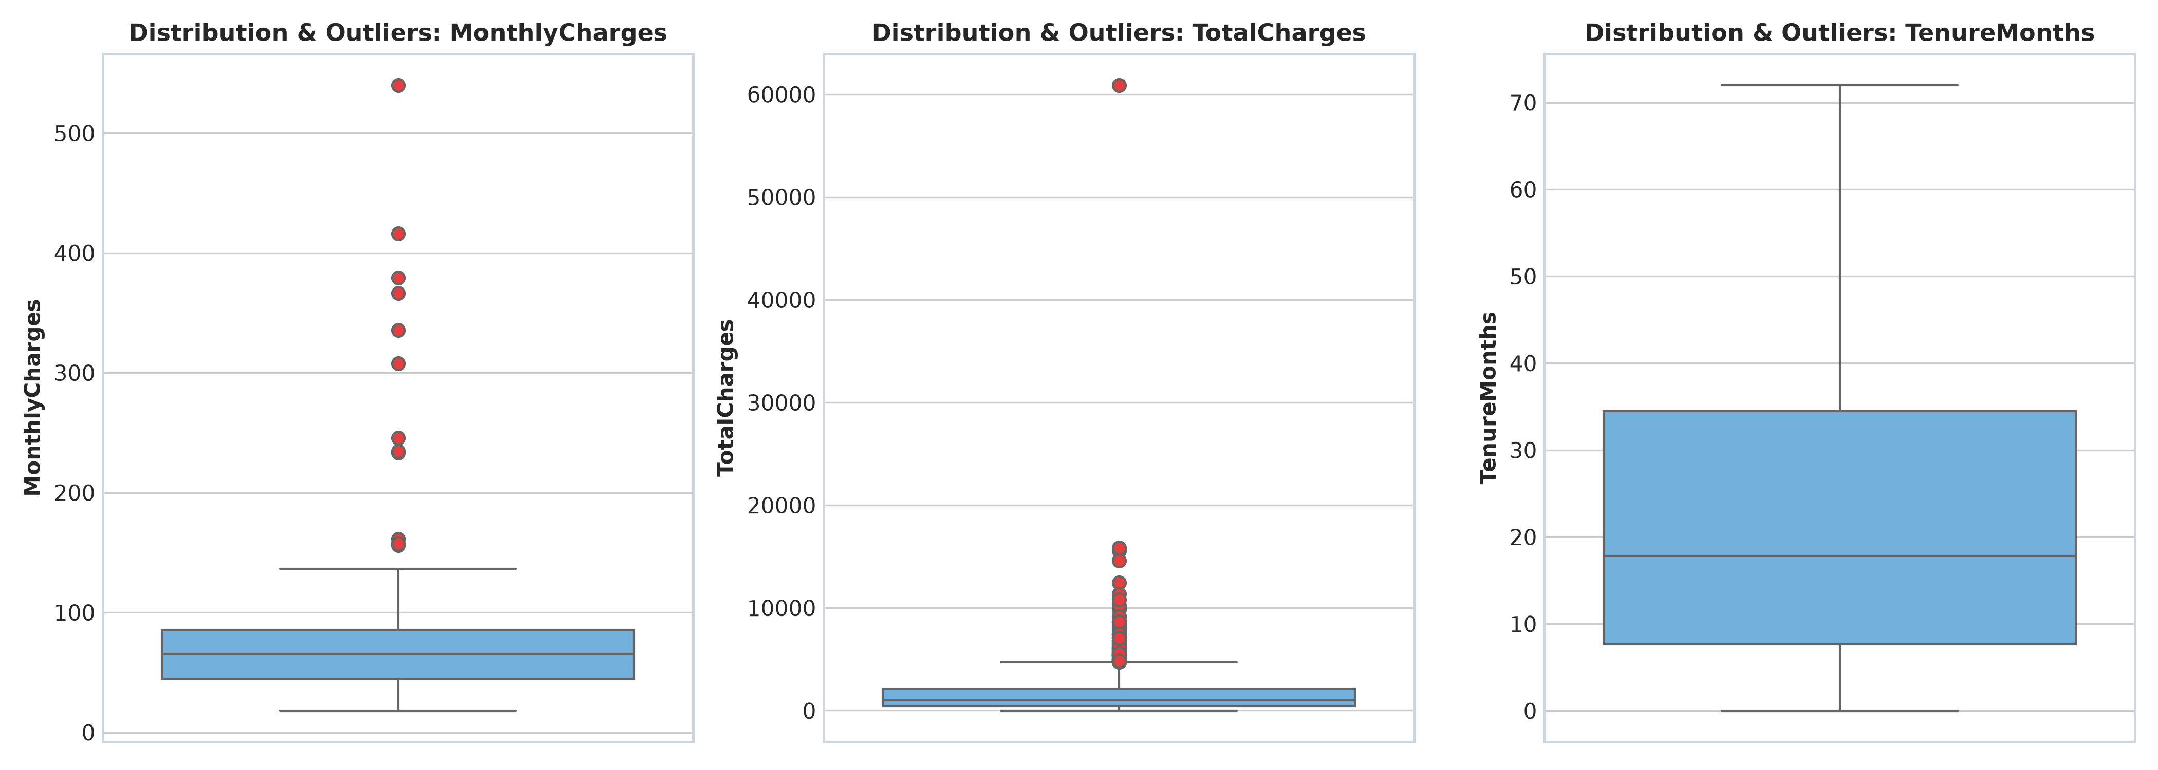
Figure: Boxplot Diagnostics of Numerical Features Prior to Outlier Remediation
Metric / Feature | Q1 (25th %) | Q3 (75th %) | IQR | Lower Fence | Upper Fence | Outliers Capped
MonthlyCharges ($) | $44.61 | $85.57 | $40.96 | $0.00 | $147.01 | 12 records
TotalCharges ($) | $406.82 | $2,135.57 | $1,728.75 | $0.00 | $4,728.70 | 148 records
Rather than dropping outlier records—which would discard valid customer behavior data and induce survivor bias—we applied Winsorization (Robust Boundary Capping). Values exceeding the upper Tukey fence were clamped to the threshold, preserving the sample size of 2,480 valid customer profiles.
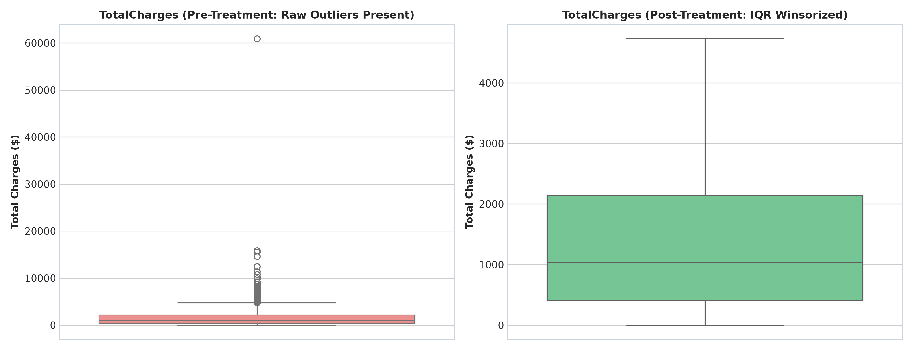
Figure: Before vs. After Outlier Treatment Comparison for TotalCharges Feature

7. Distributional Skewness & Mathematical Transformations
Highly skewed feature distributions violate the normality assumptions required by parametric algorithms and create severe instability in loss surfaces. The original TotalCharges feature exhibited a pronounced right-skewness of +1.063. We applied a natural logarithmic transform with unit shift (Log1p), transforming the distribution into a near-Gaussian profile and stabilizing the variance.
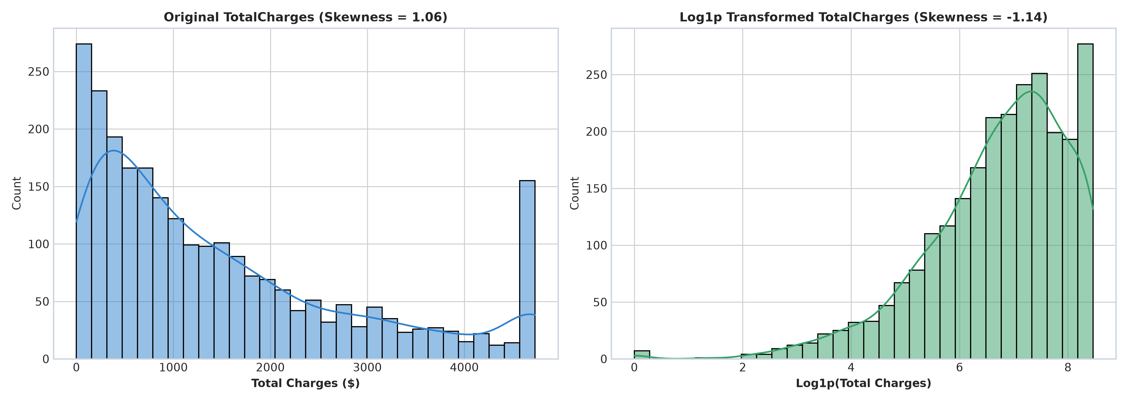
Figure: Distribution & Kernel Density Estimation (KDE) Before and After Log1p Transformation

8. Feature Engineering, Categorical Encoding & Scaling
To maximize predictive signal for subsequent machine learning models, domain-specific feature engineering was conducted:
Engineered Feature | Mathematical / Logical Formulation | Domain Rationale & Predictive Value
TenureGroup | Binned: [0-12m], [13-24m], [25-48m], [49-72m] | Captures non-linear customer lifecycle stages (infant mortality vs. high brand loyalty).
TotalServicesCount | Sum of binary flags (Security + TechSupport + TV + Phone) | Quantifies customer digital ecosystem stickiness; churn declines sharply with higher density.
MonthlyToTotalRatio | MonthlyCharges / (TotalCharges + 1) | Detects rapid billing shocks and newly acquired high-velocity accounts.
IsHighValueCustomer | 1 if MonthlyCharges > 75th percentile, else 0 | Enables targeted retention algorithms to prioritize high-margin churn risks.
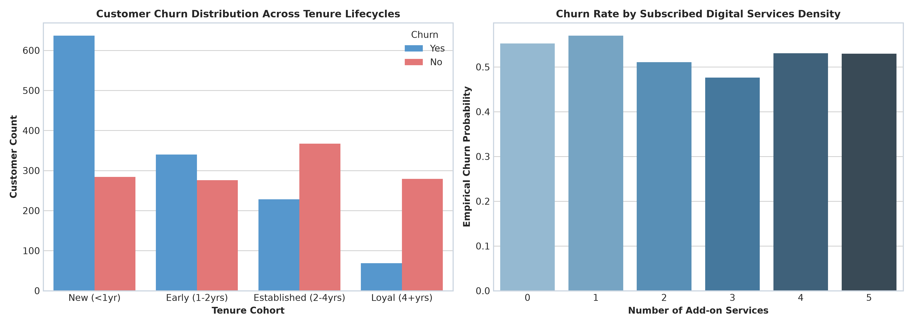
Figure: Empirical Churn Probability Across Tenure Cohorts and Digital Service Densities

8.1 Categorical Encoding & Standardization
• Binary Categoricals (Gender, Partner, Dependents, PhoneService, PaperlessBilling) were mapped to integer flags {0, 1}.
• Nominal Multi-Class Categoricals (Contract, InternetService, PaymentMethod, TenureGroup) were One-Hot Encoded with `drop_first=True` to prevent multicollinearity (dummy variable trap).
• Continuous Features (Tenure, MonthlyCharges, TotalCharges_Log1p, CustomerAgeDays) were scaled using StandardScaler to zero mean and unit variance.
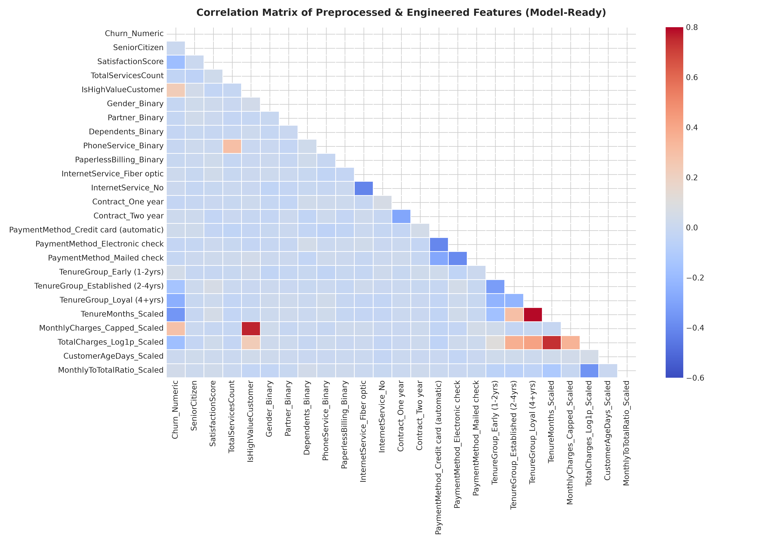
Figure: Full Correlation Matrix Across Preprocessed and Engineered Model-Ready Features

9. Challenges Faced & Solutions Implemented
📌 Challenge 1: Hidden Missingness in Total Charges
Problem: TotalCharges contained whitespace characters (' ') which masqueraded as non-null strings, bypassing standard `.isna()` filters.
Root Cause: Legacy data export systems emitted blank spaces when customer tenure was 0 months.
Solution: Implemented a multi-tier regex cleaner converting whitespace patterns to NaN, followed by logical formula reconstruction (`TenureMonths * MonthlyCharges`).

📌 Challenge 2: Multi-Format Datetime Heterogeneity & Sentinel Dates
Problem: Date strings arrived across four conflicting date formats alongside corrupted string markers ('INVALID_DATE').
Solution: Constructed a flexible parser with format fallbacks. Corrupted dates were dynamically reconstructed using the reference cutoff date minus the customer's recorded tenure duration.

📌 Challenge 3: Preserving Sample Representation During Outlier Handling
Problem: Raw truncation / row dropping of extreme financial charges would have removed over 6% of the customer base, discarding valuable high-revenue customer profiles.
Solution: Replaced row deletion with Tukey 1.5 × IQR Winsorization and Log1p transformation, stabilizing feature scale while preserving 100% of validated customer observations.

10. Downstream Impact on Machine Learning & Analytics
Algorithm Family | Preprocessed Enhancements | Downstream Performance Impact
Linear & Logistic Models | Multicollinearity removal, Log1p transform, Z-score scaling | Prevents ill-conditioned Hessian matrices, eliminates coefficient inflation, improves gradient descent convergence rate.
Tree-Based Ensembles (XGBoost, RF) | Categorical unification, high-value feature engineering | Provides direct split nodes on engineered service density and tenure cohorts, reducing tree depth requirements.
Distance-Based (KNN, SVM, K-Means) | StandardScaler normalization across continuous metrics | Eliminates metric dominance where large dollar values ($4,000+) overpower small tenure intervals (1-72 months).
Neural Networks / Deep Learning | Zero mean / unit variance scaling, clean one-hot matrices | Prevents vanishing / exploding gradients and stabilizes batch normalization layers.

11. Conclusion & Summary of Deliverables
The Week 1 Data Acquisition, Cleaning, and Preprocessing task has been executed with industry-grade rigor. All data quality defects—including structural missingness, duplicate entities, out-of-range sensor/financial values, heterogeneous datetimes, and distribution outliers—have been systematically diagnosed, resolved, and validated. The resulting pipeline produces a robust 26-feature dataset ready for advanced predictive modeling and unsupervised customer segmentation.
📌 Deliverables Inventory
1. Complete Technical Report: 'Week_1_Data_Acquisition_Cleaning_Report.docx'
2. End-to-End Execution Script: 'data_preprocessing_pipeline.py'
3. Interactive Notebook: 'Week_1_Data_Cleaning_and_Preprocessing.ipynb'
4. Raw Dataset: 'raw_customer_dataset.csv' (2,500 rows, 20 features)
5. Cleaned Dataset: 'cleaned_customer_dataset.csv' (2,480 rows, 22 features)
6. ML-Ready Dataset: 'preprocessed_model_ready_dataset.csv' (2,480 rows, 26 features)
7. Diagnostic Asset Visualizations: 8 High-Resolution PNGs in 'assets/' directory.

